Operating Systems, Security and Network
Lab Report 2: C Programming Basics & GCC Compilation Stages
Student Name: Kshitish Pandit | Module: ST5003CMD | Softwarica College

Part I: GCC Installation and Verification
We ran the commands below to verify that the build-essential development suite and GCC compiler were installed on our Linux system.
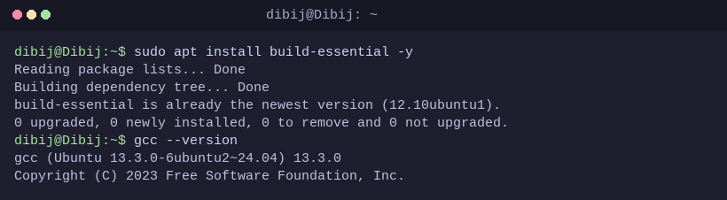
Description: Verified GCC compiler installation and checked version (gcc 13.3.0).

Part II: The Four Stages of GCC Compilation
Step 1: Source Code Creation (hello.c)
Command: nano hello.c
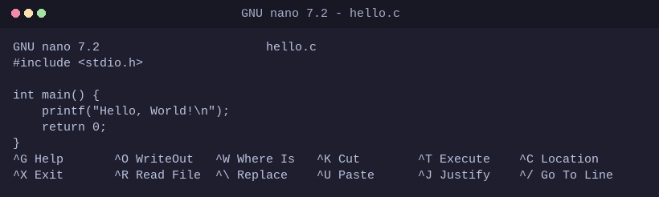
Description: We ran this command to create our initial hello.c source file using the nano text editor.

Step 2: Preprocessing Stage (-E -> hello.i)
Command: gcc -E hello.c -o hello.i
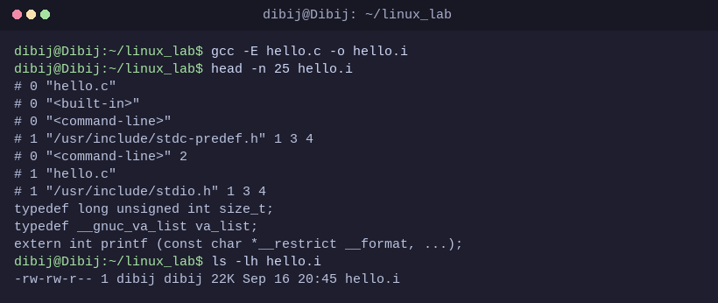
Description: We ran this command to expand all header files and macros into preprocessed C code (.i file).

Step 3: Compilation Stage (-S -> hello.s)
Command: gcc -S hello.i -o hello.s
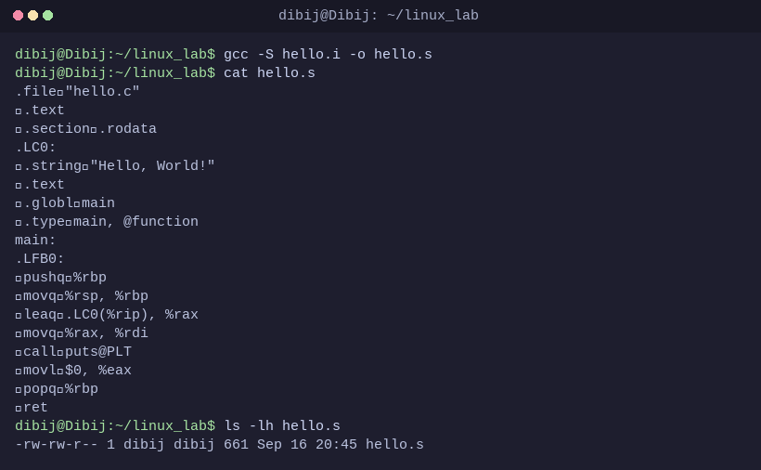
Description: We ran this command to translate preprocessed C code into x86-64 assembly instructions (.s file).

Step 4: Assembly Stage (-c -> hello.o)
Command: gcc -c hello.s -o hello.o
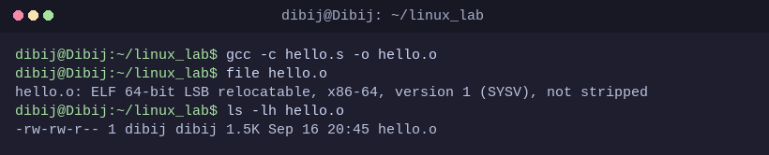
Description: We ran this command to assemble human-readable assembly instructions into machine-code relocatable object format (.o file).

Step 5: Linking Stage (hello.o -> hello)
Command: gcc hello.o -o hello && ./hello
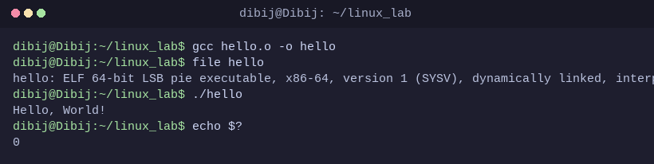
Description: We ran this command to link the object file with the C standard library (glibc) into a runnable binary and execute it.

Part III: Lab Practical Tasks Completed
Task 1 & 2: Testing Return Values and Exit Status ($?)
Command: gcc exit_status.c -o exit_status && ./exit_status && echo $?
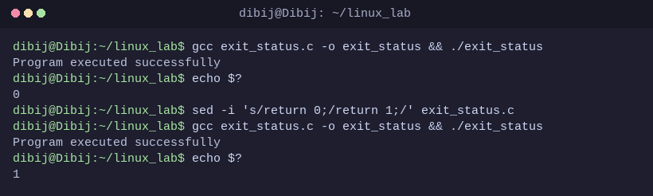
Description: We ran this command to compile and verify return 0 (success) vs return 1 (error code) using echo $? in Bash.

Task 3: Program Accepting User Input (user_input.c)
Command: gcc user_input.c -o user_input && ./user_input
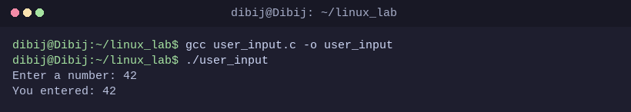
Description: We ran this command to compile and execute a program reading integer values via scanf() and displaying them via printf().

Task 4: Program with Multiple Formatted Inputs (user_info.c)
Command: gcc user_info.c -o user_info && ./user_info
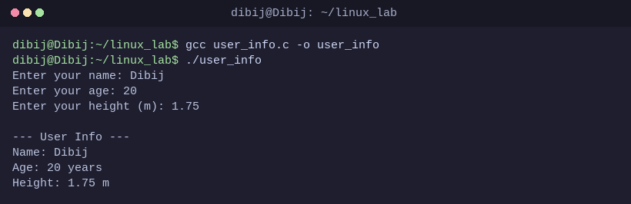
Description: We ran this command to test reading and printing multiple format specifiers (%s, %d, %.2f) for user information.

Task 5: Program Returning Custom Status Code 50 (return_fifty.c)
Command: gcc return_fifty.c -o return_fifty && ./return_fifty && echo $?
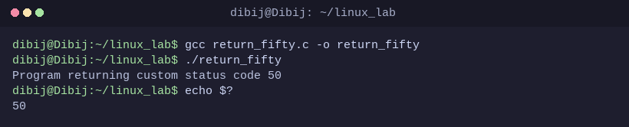
Description: We ran this command to demonstrate returning a custom non-zero return code (50) and capturing it with echo $?.

Part IV: Knowledge Check Questions & Solutions
Question 1: What is the purpose of the #include directive in C programming? Provide an example of its usage.
Answer: The #include directive is a preprocessor instruction telling the C precompiler to insert the contents of an external header file into the current source code before compilation begins. Header files declare standard functions, macros, and data types. For example, #include <stdio.h> grants access to standard input/output functions such as printf() and scanf().

Question 2: Explain the difference between the four stages of compilation. What file extension is produced at each stage?
Answer:
1. Preprocessing (.i): Expands all macros (#define), removes comments, and includes header files into pure C code.
2. Compiling (.s): Translates preprocessed C code into machine-specific assembly language instructions.
3. Assembling (.o): Converts assembly mnemonics into relocatable binary machine instructions.
4. Linking (no extension / executable): Combines object code with required runtime startup code and standard library functions into a finalized executable binary.

Question 3: What does a return value of 0 from the main() function indicate to the operating system? What about a non-zero return value?
Answer: In standard POSIX and Linux conventions, returning 0 from main() signals successful program completion without errors. A non-zero return value (such as 1, 2, or 50) signals an abnormal termination or specific error state back to the operating system, which calling shells can inspect using echo $?.

Question 4: What GCC command would you use to: 1) Only preprocess without compiling? 2) Generate assembly but not assemble? 3) Create object file without linking?
Answer:
1) Only preprocess: gcc -E file.c -o file.i
2) Only generate assembly: gcc -S file.c -o file.s
3) Only create object file: gcc -c file.c -o file.o

Question 5: Write a C program declaring an integer variable, asking the user for input, and displaying it back.
Answer:
#include <stdio.h>
int main() {
int number;
printf("Enter a number: ");
scanf("%d", &number);
printf("You entered: %d\n", number);
return 0;
}

Question 6: Explain why C is called a 'compiled language' and how this differs from interpreted languages.
Answer: C is called a compiled language because its human-readable source code must be translated ahead-of-time directly into native machine code (CPU architecture instructions) by a compiler before execution. In contrast, interpreted languages (like Python or JavaScript) execute instructions dynamically line-by-line via an interpreter runtime at execution time, which offers greater portability but typically lower execution efficiency compared to compiled binaries.

